Output of the code of Team Budget Planner

1.When we run our program

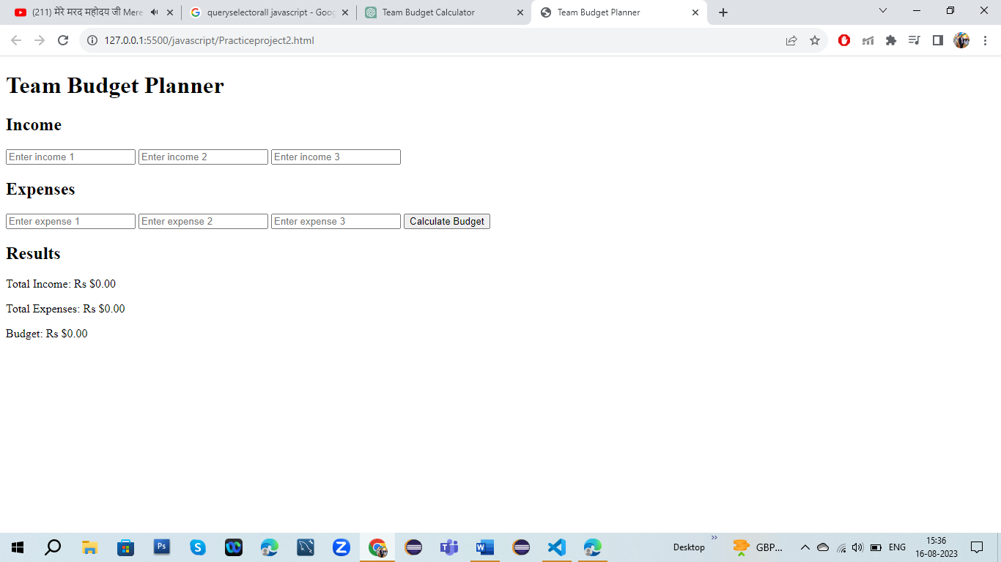

2.When we put detail whatever I have earned income and whatever I have expanses

